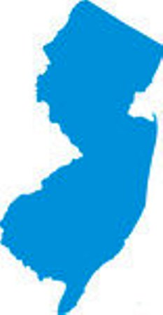

New *Jersey State Organization of Executive Director:* Debra Sikkema

*CYSTIC FIBROSIS* Administrative Assistant:  Bernice DeMeritt  *Est. 1977 Grant* Administrator*: Timothy Roberts*

*"We are the ones who help them breath easier ! "* Adult Spokesperson: *George McDermott NJSOCF*

### ***137 Union Blvd, Totowa NJ 07512***

Phone : 973-595-1232

Fax : 973-595-1718

www.njsocf.org

### ***2013******BOWL * 4 * Cystic Fibrosis Awareness***

#### *SATURDAY – NOVEMBER 16 - 7:30 PM - ?*

# https://encrypted-tbn0.gstatic.com/images?q=tbn:ANd9GcSJ-2k6o0BIrAddUy0gLylz6w97R2r3GWIYuDTyf3T618fO2xBJ ***New North Arlington Bowl Inc.***

# ***200 SCHUYLER AVE***

# ***NORTH ARLINGTON, NEW JERSEY***

# ***SPONSORSHIP / PARTICIPATION FORM***

*Name*

***NAME OF PERSON TO CONTACT***

*Contact # E-mail @*

*( ) Check if you would not mind an email for next year's event*

*Address*

*City State Zip Code*

*LANE # ____ LANES ASSIGNED ON 1ST COME / 1ST SERVE BASIS, ONCE PAYMENT IS RECEIVED YOUR LANE WILL BE ASSIGNED*

**PLEASE CHECK BOX FOR HOW YOU WOULD LIKE TO HELP ME HELP OTHERS WITH CYSTIC FIBROSIS**

###### PLATINUM SPONSOR - $250.00 (100% Tax Deductible) Lane + Co. name on shirt

*[ ] It is our pleasure to sponsor a Lane @ the NJSO of Cystic Fibrosis*

*"Bowl – 4 – Awareness" Enclosed is our donation of $250.00.*

###### GOLD SPONSOR - $200.00 (100% Tax Deductible)

*[ ] It is our pleasure to sponsor a Lane @ the NJSO of Cystic Fibrosis* **Lane + Co. name on shirt** *" Bowl – 4 – Awareness" Enclosed is our check in the amount of $200.00*

***SILVER SPONSOR*** *-* ***$175.00*** *(100% Tax Deductible)*

*[ ] It is our pleasure to Reserve a Lane / Participate @ the NJSO of Cystic Fibrosis “Bowl -4 – Awareness" Enclosed is our donation of $175.00 for our team.*

***$ 35.00 per person or choose a sponsor package above***

***\*\*\* The night will include (3) games of bowling Scotch Doubles- 3 couples pairing up – 1st bowler throws 1 ball, then 2nd person throws 2nd ball on same frame \*\*\****



*Bowlers:*

*RETURN THIS FORM WITH YOUR CHECK MADE PAYABLE TO:*

***NJSOCF***

***P.O. Box 3648***

***Wayne, NJ 07474-3648***

***ANY QUESTIONS PLEASE CALL George McDermott CF Adult @ (201) 954-6144 or email: gmcdermott_1@verizon.net or NJSOCF @ (973) 595-1232***

*Please respond before* **November 10th, 2013**