New Jersey State Organization of Cystic Fibrosis
Presents
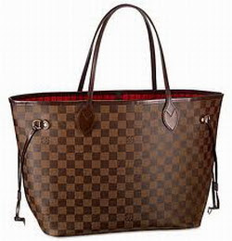
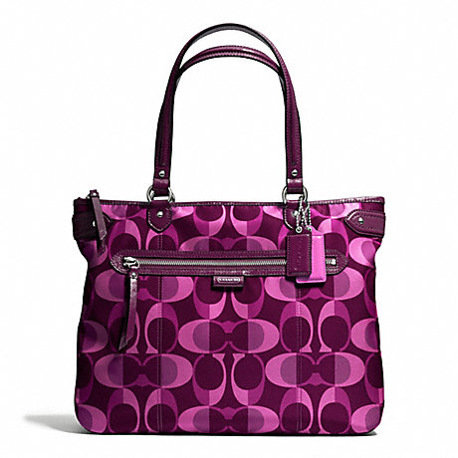
“POCKETBOOK BINGO”
Designer Handbags
Coach
Michael kors
Kate spade

Thursday, April 12, 2018

Pompton Lakes Elks Lodge
15 Perrin Avenue, Pompton Lakes, New Jersey
Doors Open – 6:00 PM Calling Begins – 7:00

Admission: $25.00
includes 12 Bingo Sheets/3 Boards per game

Additional boards and daubers will be available to purchase.
Snack bar will be open for food and beverage, or feel free to bring your own.
No alcoholic beverages are allowed on premises.
No one under 18 years old will be admitted.

THIS EVENT SELLS OUT QUICKLY – RESPOND NOW!!!

--------------------------------------------------------------------------------------------------------------------------------------------------------------------------------
Please make checks payable to: New Jersey State Organization of Cystic Fibrosis (NJSOCF)
$25 per ticket
Mail payment and this form to:

Phone: 973-595-1232 New Jersey State Organization of Cystic Fibrosis www.njsocf.org
FAX: 973-595-1718 P.O. Box 3648, Wayne, NJ 07474-3648

Name_________________________________________ Telephone #__________________________
Address_______________________________________ Email________________________________
City__________________________________________________State_______________Zip_________
Number of Tickets______________________ Total Amount Enclosed______________________________

Please charge my donation to my: □ Visa □ Mastercard □ AMEX

Credit Card Number___________________________________________ Expiration Date______________
Name on Card________________________________ Signature___________________________________

I a

