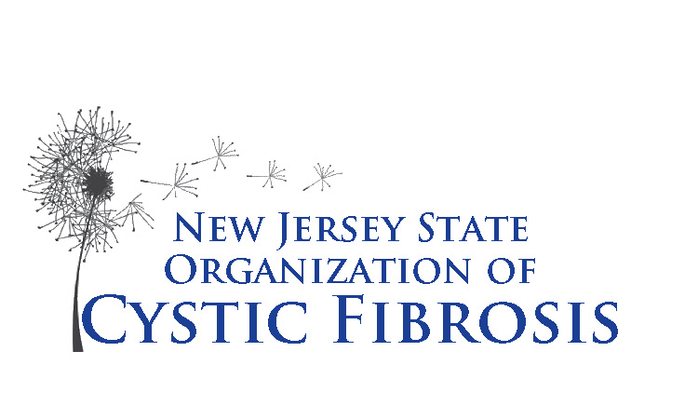
New Jersey State Organization
Of Cystic Fibrosis

137 Union Boulevard
Totowa, NJ 07512
973-595-1232 ● Fax 973595-1718
Email: das@njsocf.org

Pharmaceutical Services for Adults with Cystic Fibrosis

Guidelines
Grant Year July 1, 2022 – June 30, 2023

NJSOCF will reimburse for the following:
- Copayments for prescription medications related to the treatment of cystic fibrosis
- Copayments for office visits related to the treatment of cystic fibrosis
- Copayments for diagnostic testing, i.e., routine lab work, scans, x-rays and sputum cultures, related to the treatment of cystic fibrosis
- Out-of-pocket expenses for Home IV antibiotics
- Copayments for respiratory equipment and supplies
- Insurance deductibles up to a maximum of $1,000 per year

How to submit your bills for reimbursement

Always make copies of your bills or whatever you are sending through the mail.

For prescription copay reimbursement we need:
- Name of the prescribing physician and pharmacy
- Date the prescription was filled
- Name of the medication
- Amount paid*
- Reimbursement will not be made for register/credit card receipts.

For office visits and diagnostic copay reimbursement we need:
- Name of the physician
- Date of visit or procedure
- Name of procedure or reason for visit
- Amount paid*

*We can also pay directly to your provider

- Please submit all bills and receipts on a monthly or quarterly basis to insure reimbursement.

- If you do not have prescription insurance coverage you must first apply to see if you qualify for Rx assistance programs. Please call the office to discuss any needs you may have.

- You must do your shopping for nutritious foods on a monthly basis.

- Please notify NJSOCF with any name or address changes, insurance changes or the need for equipment.
New Jersey State Organization
Of Cystic Fibrosis

137 Union Boulevard
Totowa, NJ 07512
973-595-1232 ● Fax 973595-1718
Email: das@njsocf.org

Pharmaceutical Services for Adults with Cystic Fibrosis

Food and Nutritional Supplements

- There is a monthly benefit for nutritious foods and supplements
- Shopping should be done every month for approved foods and/or nutritional supplements
- You must send back your itemized grocery receipt(s) each month in the postage paid envelope provided. You will not get another card until a receipt is received.
- If you don’t receive your gift card by mid-month call or email das@njsocf.org to inquire.

Please note that only nutritious and non-taxable food items should be purchased. If for some reason you cannot shop in any one month, please call or email us.

EXAMPLES OF UNACCEPTABLE PURCHASES

Soda and non-nutritious drinks
Coffee and regular tea
Spices and condiments
All candy

ALL TAXABLE ITEMS ARE UNACCEPTABLE

Paper and plastic products
Laundry products
Cleaning products
Grooming and cosmetic aides

EXAMPLES OF ACCEPTABLE NUTRITIONAL SUPPLEMENTS

Vitamins
Boost
Ensure products
Carnation Instant Breakfast
Glucerna
Scandishake
Power bars and equivalents
Weight gain supplements

Please call the office to discuss any special nutritional supplement needs you may have.

For more information on any of the above, call us at (973) 595-1232 or email das@njsocf.org.

