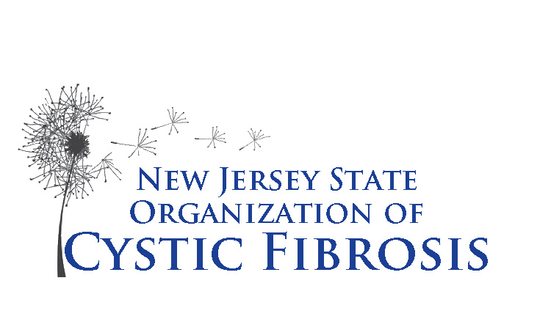
New Jersey State Organization
Of Cystic Fibrosis

137 Union Boulevard
Totowa, NJ 07512
973-595-1232 ● Fax 973595-1718
Email: das@njsocf.org

NJSOCF Adult Assistance Program

Guidelines
ProgramYear July 1, 2025 – June 30, 2026

NJSOCF will reimburse for the following:
- Copayments for prescription medications related to the treatment of cystic fibrosis
  - CF Modulator Drugs including Trikafta, Symdecko, Kakydeco
  - Pancreatic Enzymes including Creon, Pancreaze, Zenpep, Ultresa, Pertzye & Viokace
  - Bronchodilators including Albuterol, Pro Air, Provento, Levabuterol, & Xopenex
  - Antibiotics to treat CF infections only
  - Mucus Reduction Drugs including Pulmozyme, Dornase alfa, Cayston & Tobramycin
  - Hypertonic Saline
  - GI Drugs including Linzess, Miralax & Motegrity
  - Asthma Inhalers including Advai & Symbicort
- Copayments for office visits related to the treatment of cystic fibrosis including CF Center doctor visits, Endocrinologist doctor visits & GI doctor visits.
- Copayments for diagnostic testing, i.e., routine lab work, scans, x-rays and sputum cultures, related to the treatment of cystic fibrosis
- Out-of-pocket expenses for Home IV antibiotics
- Copayments for respiratory equipment and supplies including nebulizer, air purifiers & Oxygen
- Insurance deductibles up to a maximum of $1,000 per year
- Mental Health office visits
- Nutritional Supplements
- Vitamins A, D, E & K, C & B-complex & Calcium

How to submit your bills for reimbursement

Always make copies of your bills or whatever you are sending through the mail.

For prescription copay reimbursement we need:
- Name of the prescribing physician and pharmacy
- Date the prescription was filled
- Name of the medication
- Amount paid*
- Reimbursement will not be made for register/credit card receipts

.

New Jersey State Organization
Of Cystic Fibrosis

137 Union Boulevard
Totowa, NJ 07512
973-595-1232 ● Fax 973595-1718
Email: das@njsocf.org

NJSOCF Adult Assistance Program

Guidelines
Program Year July 1, 2025 – June 30, 2026

For office visits and diagnostic copay reimbursement we need:
- Name of the physician
- Date of visit or procedure
- Name of procedure or reason for visit
- Amount paid*

*We can also pay directly to your provider

- Please submit all bills and receipts on a monthly or quarterly basis to insure reimbursement.

- If you do not have prescription insurance coverage you must first apply to see if you qualify for Rx assistance programs. Please call the office to discuss any needs you may have.

- Please notify NJSOCF with any name or address changes, insurance changes or the need for equipment.

